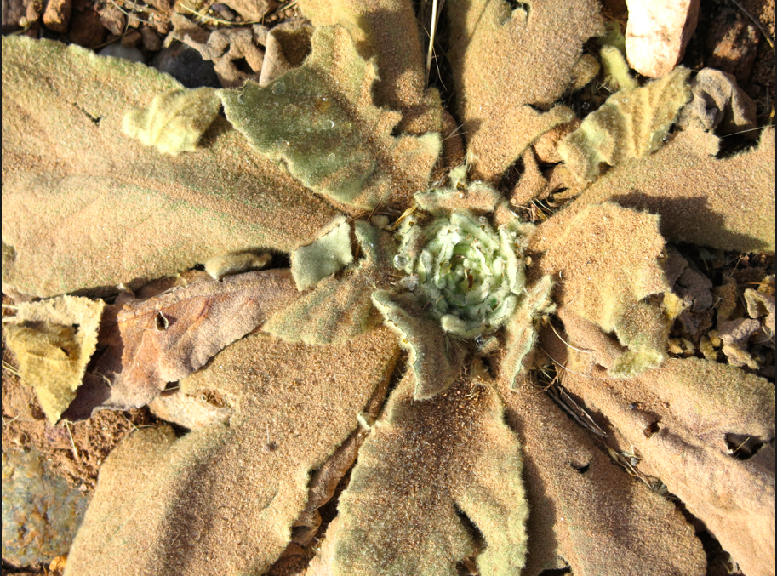to survive painlessly, if possible, I must needs write what is inconsequential for the others.

to write what is necessary is painfully inconceivable and *realmente me cuesta demasiado*.

it wouldn’t be as drama a romance if I shouted in english at you, *linda mujer*,

in the middle of a pure spanish long distance dialogue.

besides eye drops to acclimate to dry spells stretched thin between outbursts of emotion,

I got a prescription for glasses — should I want them / leave it / take it / who gives a second thought.

I’ve been employing the backslash that I think should be a regularly accepted

default schism to signify the split / in our human-unkind soul, my inconsistency / gigantic vacillation

that I cannot confirm because I / cannot / escape.

*Jamás puedo averiguar si realmente no estoy exagerando mis cosas.*

there exists a seemingly unprecedented / inoperable break between every yesterday,

todays that I cannot possibly imagine.

the broken day when I sat in my too-small bed,

when I witnessed an intouchable halo

made wide around the moon,

when I read you *The Runaway Rabbit*

which rings true now that I’m already making plans

*para evitar que seamos siempre huyendo de la otra, contra nuestra voluntad*.

I may not be able to recall with increasingly foreign words what exactly was said on what date,

where I placed something important, how to behave rationally without you

especially at a roadhouse restaurant eating deceptively benign vegetable stew.

can you tell me when social cultivation is a lost cause?

when I can confidently say I’ve stockpiled hundreds of screenshot stills from films & shows that I have to name them *Felicity* 6, 7, 8, 9, *Heathers* 11, 12, 15, *The L-Word* 10, *Life in a Day* 20 and 21?

is it when we cry at the softness of a red leaf

and when we can do it on the shoulder of the nearest person,

not just the nearest to our heart?

when we know it’s better to be too careful than reckless?

or when our conscience has finally met us with maximum heckling and we buckle?